1 Лаба

Рыжевский

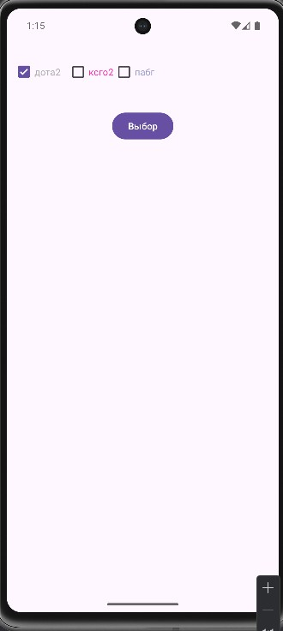

Activity_main.xml

<?xml version="1.0" encoding="utf-8"?>

<LinearLayout xmlns:android[="http://schemas.android.com/apk/res/android"](http://schemas.android.com/apk/res/android) xmlns:app[="http://schemas.android.com/apk/res-auto"](http://schemas.android.com/apk/res-auto) xmlns:tools[="http://schemas.android.com/tools"](http://schemas.android.com/tools) android:id="@+id/main"

android:layout_width="match_parent" android:layout_height="match_parent" android:padding="75dp"

android:orientation="vertical" tools:context=".MainActivity">

<LinearLayout

android:layout_width="249dp" android:layout_height="102dp" android:orientation="horizontal" android:padding="10dp">

<CheckBox

android:id="@+id/cbdotakrutaya" android:layout_width="82dp" android:layout_height="68dp" android:text="дота2"

android:textColor="@color/material_dynamic_neutral70" />

<CheckBox

android:id="@+id/cbxsgovno" android:layout_width="wrap_content" android:layout_height="wrap_content" android:text="ксго2" android:textColor="@color/hellyee2" />

<CheckBox

android:id="@+id/cbrabg" android:layout_width="wrap_content" android:layout_height="wrap_content" android:text="пабг" android:textColor="@color/hellyee" />

</LinearLayout>

<Button

android:id="@+id/btnChoose" android:layout_width="wrap_content" android:layout_height="wrap_content" android:layout_gravity="center" android:text="Выбор" />

<TextView

android:id="@+id/tvChoose" android:layout_width="wrap_content" android:layout_height="wrap_content" android:textSize="16sp" android:layout_gravity="center"/>

</LinearLayout>

Colors.xml

<?xml version="1.0" encoding="utf-8"?>

<resources>

<color name="black">#FF000000</color>

<color name="white">#FFFFFFFF</color>

<color name="hellyee">#9999CC</color>

<color name="hellyee2">#CCFC0099</color>

</resources>

MainActivity.kt

package com.example.omgkucherenko

import android.os.Bundle

import androidx.activity.enableEdgeToEdge import androidx.appcompat.app.AppCompatActivity import androidx.core.view.ViewCompat

import androidx.core.view.WindowInsetsCompat

class MainActivity : AppCompatActivity() {

override fun onCreate(savedInstanceState: Bundle?) { super.onCreate(savedInstanceState) *enableEdgeToEdge*() setContentView(R.layout.*activity_main*)

ViewCompat.setOnApplyWindowInsetsListener(findViewById(R.id.*main*)) **{**

v, insets **->**

val systemBars = insets.getInsets(WindowInsetsCompat.Type.systemBars())

v.setPadding(systemBars.left, systemBars.top, systemBars.right, systemBars.bottom)

insets

**}**

}

}